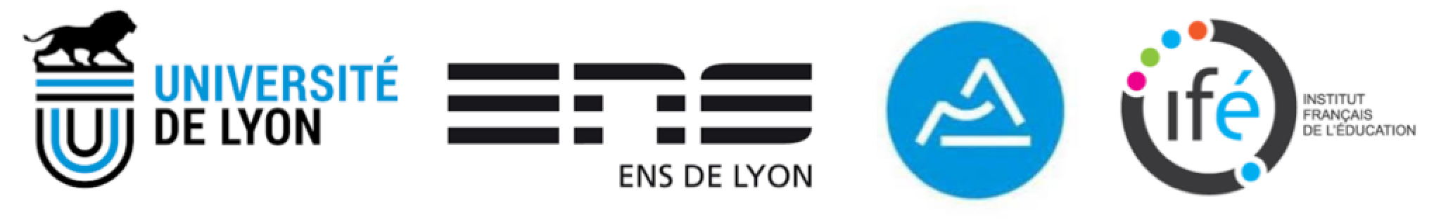
Re(s)sources 2018
Conference 28-29-30 May 2018, French Institute of Education, ENS de Lyon, France
First call for contributions, July 1st 2017
Comprendre le travail des professeurs à partir de leurs interactions avec les ressources de leur enseignement : dix ans après l’émergence de l’approche documentaire du didactique, chantiers en cours, croisements théoriques, éclairages internationaux et programmes de recherche
Understanding teachers’ work through their interactions with resources for teaching: ten years after the emerging of the documentational approach to didactics, work in progress, theoretical networking, international enlightening and programs of research
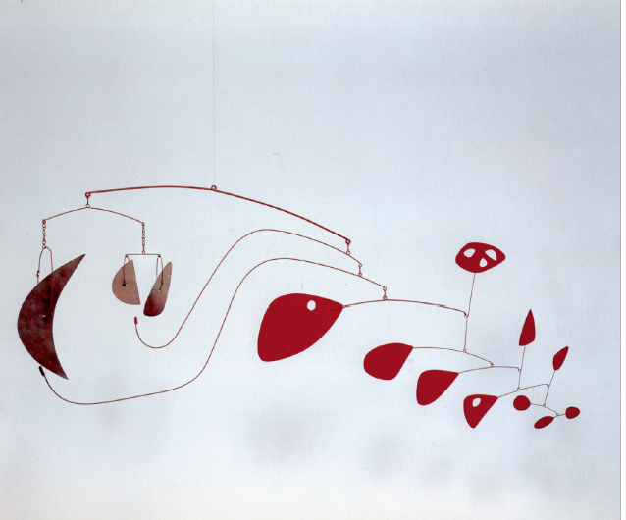
Le développement de l’Internet, et, comme conséquences, le foisonnement de ressources numériques et l’émergence de nouvelles formes de travail collectif, conduisent à des bouleversements des formes de l’enseigner et de l’apprendre. Ces bouleversements ont suscité de nouveaux besoins théoriques : comment analyser le travail que les professeurs conduisent pour concevoir la matière de leur enseignement ? Comment penser les relations entre le travail individuel et le travail collectif des enseignants ? Comment suivre, dans la durée, les processus en jeu ?
Ces besoins ont conduit, il y a dix ans, dans le domaine de l’enseignement des mathématiques, à la proposition d’une nouvelle approche théorique, l’approche documentaire du didactique (Gueudet & Trouche, 2009). Cette approche s’est développée en relation avec d’autres approches du domaine, en France et au niveau international. Elle a nourri une vingtaine de thèses, a rencontré d’autres cadres de recherche à travers le développement de programmes de recherche au niveau national (ANR ReVEA en France par exemple) ou international (projets européens comme MC2 ; projets en Argentine, au Brésil, en Chine, au Liban ou encore au Sénégal). Le domaine d’application initial, l’enseignement des mathématiques au second degré, a été étendu, de la maternelle à l’enseignement supérieur, et pour d’autres disciplines : langues, biologie, chimie, physique.
Dans cette dynamique, l’approche s’est enrichie de nouveaux concepts (ressources filles – ressources mères, méta-ressource, affinité disciplinaire, incident documentaire, expertise documentaire ou encore trajectoire documentaire) ; la méthodologie d’investigation réflexive s’est développée dans plusieurs directions, en particulier pour l’analyse des formes collectives de travail documentaire. Dans cette dynamique aussi, de nouvelles questions sont apparues, mettant en évidence la nécessité de nouveaux programmes de recherche. C’est pour faire le point de ces avancées et de ces questions qu’est organisé ce colloque de trois jours.
The development of the Internet and, as consequences, the abundance of digital resources and the emergence of new forms of collective work, lead to new developments and uncertainties in teaching and learning. These upheavals have given rise to new theoretical needs: how to analyze teachers’ work when they prepare for their teaching? How to conceptualise the relationships between individual and collective work? How to follow the related processes over the long term?
Ten years ago these theoretical and practical needs led to the proposal of a new frame, the documentational approach to didactics, in the field of mathematics education (Gueudet & Trouche, 2009) This approach has developed in relation to other approaches in the field, in France and internationally. It has fostered about twenty theses, crossed other theoretical frames throughout the development of research programs at the national level (ANR ReVEA in France for example) or international (European projects such as MC2, projects in Argentina, Brazil, China, Lebanon or Senegal). The initial field, mathematics at secondary school, has been expanded from Kindergarten to University, and to other fields of application: languages, biology, chemistry, physics.
Alongside these developments the approach has been enriched by new concepts (daughters resources - mother resources, meta-resources, disciplinary affinity, documentational incident, documentational expertise or documentational trajectory); the methodology of reflective investigation has developed in several directions, in particular for the analysis of collective forms of documentation work. At the same time new questions have emerged, highlighting the need for new research programs. It is to take stock of these advances and questions that this three-day conference is organized.

Gueudet, G., & Trouche, L. (2009). Towards new documentation systems for mathematics teachers? Educational Studies in Mathematics, 71(3), 199-218.
Program
The conference will propose 7 plenary lectures, a panel discussion and 4 working groups
28th | 10h30 -11h  Welcoming | 11h - 12h  Lecture  K. Ruthven | Buffet | 14h - 15h  Lecture  G. Gueudet | 15h15 - 17h15  WG  Session 1 |  | Buffet | 20h - 21h  Lecture  C. Proust
29th | 9h - 10h  Lecture  J. Remillard | 10h15 - 12h15  WG  Session 2 | Buffet | 14h - 15h  Lecture  M. Artigue | 15h15 - 17h15  WG  Session 3 | 17h15–18h30  Poster session |  | 20h  Conf diner
30th | 9h - 10h  Lecture  T. Miyakawa & B. Xu | 10h30 - 12h30  Panel discussion  B. Pepin | Buffet | 14h - 15h  WG  Plenary reports | 15h - 16h  Lecture  L. Trouche | 16h-16h30  Closing session

Plenary lectures
Kenneth Ruthven (University of Cambridge, UK). The construct of 'resource system' as an analytic tool in understanding the work of teaching
Ghislaine Gueudet (University of Western Brittany, France). Studying teachers’ documentation work: emergence of a theoretical approach
Christine Proust (CNRS, France). What is the reality of teacher’s work, behind the design of mathematics exercises? Lesson from the scribal schools, 4000 years ago
Janine Remillard (University of Pennsylvania, USA). Teachers’ Interactions with Resources Across Cultural Boundaries
Michèle Artigue (University Paris Diderot). Reflecting on a theoretical approach from a networking perspective: the case of the documentational approach to didactics
Takeshi Miyakawa (Joetsu University of Education, Japan) & Binyan Xu (ECNU, China). Teachers collective work inside and outside school as an essential spring of mathematics teachers' documentation: Japanese and Chinese experiences
Luc Trouche (ENS de Lyon, France). Evidencing the missing resources of the documentational approach to didactics, towards new programs of research.
Scientific committee
J. Adler (University of Witwatersrand, South Africa), P. Drijvers (Utrecht University, Netherlands), V. Gitirana (Universidade Federal de Pernambuco, Brazil), G. Gueudet (University of Western Brittany, France), C. Le Henaff (University of Western Brittany, France), J. Monaghan (University of Agder, Norway & University of Leeds, UK), B. Pepin (Technical University of Eindhoven, Netherlands), J. Remillard (University of Pennsylvania, USA), S. Rezat (Universität Paderborn, Germany), H. Sabra (Université de Reims, France), M. Sokhna (Université Cheikh Anta Diop, Sénégal), L. Trouche (ENS de Lyon, France), & B. Xu (East China Normal University, China)
Organization committee
Chaired by S. Soury-Lavergne, IFÉ, ENS de Lyon

Panel discussion
Chair: Birgit Pepin
Mathematics teachers as designers
Participants: Michele Artigue (France), Veronica Gitirana (Brazil), Takeshi Miyakawa (Japan), Kenneth Ruthven (England), & Binyan Xu (China).
The goal of the panel discussion is to develop a deeper understanding of the processes involved when teachers act as designers. In this panel discussion the participants will respond to each of the following questions:
- Why: Why are teacher design activities relevant? (practical and/or scientific perspective)
- What: What would teachers design: actions, or artefacts? What are the most interesting/challenging design tasks?
- How: How would teachers design? What sorts of design approaches would they use? Would they design individually, or collectively; under which conditions; short-term, or long-term?
Subsequently, the audience will be invited to join the discussion.
Working groups
WG 1. Coordinators: Jana Trgalova (University of Lyon, France) & Moustapha Sokhna (Université Check Anta Diop, Dakar)
Teachers’ resource systems, their structure, their evolution, their mapping
WG 2. Coordinators: Catherine Loisy (ENS de Lyon, France) & Hussein Sabra (Université de Reims, France)
Analyzing teachers’ work with resources, methodological issues
WG 3: Coordinators: Sebastian Rezat (University of Paderborn, Germany) & Carole Le Henaff (University of Western Brittany, France)
Instrumentation, competencies, design capacity, expertise
WG 4: Coordinators: Paul Drijvers (Utrecht University, the Netherlands), Verônica Gitirana (Federal University of Pernambuco, Brazil) & John Monaghan (University of Agder, Norway & University of Leeds, UK).
Transitions towards digital resources: change, invariance, and orchestration

Re(s)sources 2018
Conference 28-29-30 May 2018, French Institute of Education, ENS de Lyon, France
Call for contributions
The Working Groups (WG) at the Resources Conference constitute an essential place for presentation, discussion, and collective work on specific topics related with resources. Each WG is managed by a team of two/three researchers. The WGs will work during 6 hours over 3 parallel sessions, and will make a plenary presentation synthesizing their work at the end of the conference. They will also produce a chapter in the proceedings of the conference. There are four WG, whose specific call for papers are presented below. Each contribution has to be situated in a given WG, written in English, and sent to the conference address before October 15th (see the conference agenda next page). Two kinds of contributions are possible: oral presentation or poster. The submissions are 4 pages long (oral presentation) or 2 pages (poster), both in the conference template.
WG 1. Teachers’ resource systems, their structure, their evolution, their mapping
Coordinators: Jana Trgalova (University of Lyon, France) & Moustapha Sokhna (Université Check Anta Diop, Dakar)
An important facet of teachers’ work, done outside the classroom, consists in searching for, selecting and gathering resources for lesson and assessment preparation, for inquiring about institutional requirements and constraints or for professional development. The working group focuses on issues related to this aspect of teachers’ work. The following sets of questions can be addressed:
• How do teachers constitute their resource systems? How do they search for resources and where do they get them from? What criteria do they (explicitly or implicitly) use to select new resources? How are these new resources integrated into the existing resource system? What are teachers’ representations of “good” resources? Do these representations differ according to the subject matter (mathematics, physics…), the school level (primary, secondary, tertiary), the type of activities (lesson preparation, assessment...) or other factors?
• How do the teachers structure their resource systems? Are there central / pivotal resources and what is their role? What is the place of curricular resources (prescribed curriculum) and textbooks in teachers’ resource systems?
• How do teachers’ resource systems evolve? What are the levers of their evolution (experience, cultural environment, curricular changes, teachers’ participation at professional development courses….)?
• What are the available resources (for a given subject matter, school level…)? How can these resources be mapped to learning and/or teaching objectives? How do these resources evolve with changes in society (rapid development of digital technology…) or in education (curricular changes and reforms…)?
WG 2. Analyzing teachers’ work with resources, methodological issues
Coordinators: Catherine Loisy (ENS de Lyon, France) & Hussein Sabra (Université de Reims, France)
Analyzing teachers' work with resources requires considering the work of teachers ‘as a whole’. Actually, teachers' interaction with resources is deployed in space and time. This involves taking into account activities in and out of the classroom, at home, in the lab rooms, computer rooms, etc. In addition, a teacher interacts with his/her resources from previous years, for different teaching objectives, derived from his/her involvement in different collectives over time. All of these interactions with resources determine his/her teaching experience and his teaching beliefs. Furthermore, redoubtable methodological issues would have to be taken into account, with consideration on the teaching content knowledge and on the level of teaching. The “versatility” of primary teachers determines their interactions with resources in a different way, than for secondary teachers, or higher education lecturers who have generally a dual role of teacher and of researcher. How to analyze teacher interaction with resources ‘as a whole’? How to analyze the structure of the resource system? How does this interaction take shape according to teaching contents and to levels of teaching? How to study in the long term the evolution of the interactions of teachers with resources?
WG 3: Instrumentation, competencies, design capacity, expertise
Coordinators: Sebastian Rezat (University of Paderborn, Germany) & Carole Le Henaff (University of Western Brittany, France)
Teachers use resources in order to support their teaching, to support students’ learning, and to advance their own pedagogical and content knowledge. Using resources requires particular knowledge and skills. These are conceptualized within different theoretical frames as competencies, aspects of design capacity, teacher expertise, professional knowledge, or utilization schemes within the instrumentation process. The working group focuses on empirical studies, theoretical advancements and methodological contributions related to these aspects of using resources within the documentational approach or other frameworks related to the following questions: How are these aspects of teachers’ use of resources approached theoretically and methodologically? How do these aspects develop over time in teachers’ practices? How do these aspects relate to teachers’ previous experiences and knowledge? How do these aspects relate to features of the resources and the subject matter? How do these aspects relate to teachers’ capacity to re-design them during their teaching action?
WG 4: Transitions towards digital resources: change, invariance, and orchestration
Coordinators: Paul Drijvers (Utrecht University, the Netherlands), Verônica Gitirana (Federal University of Pernambuco, Brazil), and John Monaghan (Agder University, Norway & University of Leeds, U.K.)
Digital resources have become an important part of teachers’ and students’ resource systems. The integration of digital resources into teaching and learning practices, however, raises many questions to teachers and educators. How to choose appropriate resources from the myriad of available options? How to adapt these resources to the specific learning goals at stake? How to orchestrate the students’ use of the digital resources? What do student resource systems look like? How to prepare pre- and in-service teachers for these challenging tasks? Which role can digital resources play in assessment? Which opportunities do they offer for new learning formats, such as blended learning and flipped classrooms? How do classroom experiences inform the (re)design of a digital resource? What are the options for personalized learning in adaptive environments? In this Working Group, these issues will be addressed from theoretical perspectives, including instrumental genesis, instrumental orchestration and documentational genesis.

Conference agenda
October 15th 2017, deadline for initial submissions
December 1st 2017, revisions requested sent to authors
January 15th 2018, deadline for revised version submissions
February 1st 2018, answers to the authors
February 15th, early registration
April 15th, deadline for registration
May 28-29-30th 2018, Re(s)sources conference
September 15th 2018, final versions of the texts for the proceedings
Contact: luc.trouche@ens-lyon.fr

